A. Fans will be expected to show proper sportsmanship at all times: Respect our opponents, coaches, and officials alike.
B. Wrestlers are expected to ride the bus home from competition and will be dismissed from the school. Exceptions should be rare and require approval from Mr. Qualls ahead of time.
C. Tryouts.
1. Nov 6-10 in the Auxiliary Gym, from 6:00-8:00PM.
2. The coaches want to promote and grow the sport of wrestling. Any wrestler who comes out should expect to make the team. Varsity wrestlers will be selected through experience and talent, wrestle offs will determine who competes at the Varsity level. There are plenty of spots and opportunities for all others on the JV squad to grow and develop your skills.
E. Fundraising.
1. Concessions. We will support our concessions at our home meets. Will be a mix of adult and student workers and the activities office will send out a Sign-Up Genius ahead of time to outline the requirements. Again, portion of proceeds goes back to the wrestling account.
2. Spirit Wear. Online store will open close to the tryout window with the intent of items delivered before the first meet. Will continue to list the team warm up top (hooded, blue) on the inventory for wrestlers to purchase and customize with name if they wish.
F. Schedule is posted to patriotpioneers.org, we will have 2 tournaments during the holiday break, one for varsity and one for JV (Battle at the Bridge, Dec 29-30). I will send a note out each week with time/location and ticket data.
G. Communications. Team information will be disseminated on 3 platforms:
1. The school athletics website:
https://patriotpioneers.org/main/teamschedule/id/23606/seasonid/4715804
2. Team Twitter page:
https://twitter.com/Pat_wrestling
3. Family Facebook page (Patriot Pioneer Wrestling):
https://www.facebook.com/groups/407383733383698
H. Team Rules. Will be distributed on tryout day 1. One add for this season, NO PHONES or HEADPHONES in the practice room. We only have 2 hours and need everyone’s full attention and no distractions. First offense will be a warning, second offense and the wrester will be dismissed from practice.

Varsity Schedule:
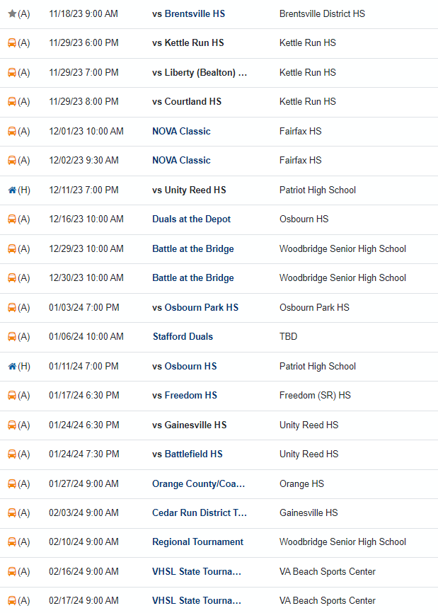

JV Schedule:
